# CIST 1520

# Scripting Technologies - JavaScript

**LAB #10 – *40 Points***

**Instructions**: Our development team has been given the project of creating a webpage for users to be able to select various cities in Georgia and get driving directions displayed using Google Maps and Directions.

Steps:

* Download and unzip the Lab 10 file.
* Get an API key from Google to use in the maps and directions API
  + Access the Google Maps API – Google Cloud Console
    - NOTE: Need google account to access.
  + Create a new project and fill in required information:
    - **Project name:** Accept the default or enter a customized name.
    - **Project ID:** Accept the default or click **EDIT** to enter a customized ID that Google APIs use as a unique identifier for your project.
    - **Billing account:** Select a billing account for the project. If you haven't set up a billing account or only have one billing account, you won't see this option.
    - **Location:** If you have an organization you want to link your project to, click **Browse** and select it; otherwise, choose "No organization".
    - Click **Create**
  + Setup billing information.
    - * NOTE: Account will not be charged if you stay within your free quota. For this project, you will not meet the quota.
    - To enable billing on a Cloud project:
    - In the Cloud Console, go to the Billing page
    - Select Cloud project.
  + Next, Enable the following APIs:
    - Click on APIs & Services 🡪 Library 🡪
      * Maps JavaScript API
      * Directions API
      * Places API
      * Distance Matrix API
    - Enable the APIs
  + Next, a unique API key needs to be created
    - Navigate to Credentials page: APIs & Services 🡪 Credentials
    - Choose Create Credentials 🡪API key
      * Note – The API Keys can be restricted but for the lab, no restrictions are needed.
    - Copy the API key to add to your code
* In index.html:
  + Enter your name and today’s date where indicated in the comment section in the document head.
  + Add script tag to access script.js file and defer it to load after page has loaded.
  + Add another script element with the following src attribute: https://maps.googleapis.com/maps/api/js?key=key&callback=showMap where key is your Google Maps API key. Also defer this script until after the page is loaded.
* In the script.js file:
  + Complete the code for the showMap()
    - Use the new google.maps.DirectionsService() object constructor to create a DirectionsService object named driveFind
    - Use the new google.maps.DirectionsRenderer() object constructor to create a DirectionsRenderer object named driveDraw
    - Create a LatLng object named city storing within it a latitude of 34.084050 and a longitude of -84.669886. (These are coordinates for the North Metro Campus)
    - Use the new google.maps.Map() object constructor to instantiate a new Google map named myMap . Set the zoom level to 12 and center the map on city
    - Create event listeners for the startingPoint and endingPoint selection lists, running the drawRoute() function in response to the change event.
    - Create the drawRoute() function with following options:
      * Insert an if statement that tests whether the selected index for the startingPoint and endingPoint selection lists are both not equal to 0. If true, then do the following:
        + Define a route object named driveRoute with an origin at startingPoint.value and a destination at endingPoint.value. Set the travelMode option to DRIVING
        + Apply the route() method to the driveFind object generating directions between the starting and ending points.

If the status of the request is “OK” :

(i) apply the setDirections() method to driveDraw object request directions from the directions service

(ii) apply the setMap() method to driveDraw to display the route within myMap,

(iii) apply the setPanel() method to driveDraw to display the turn-by-turn directions within the driveDirections object.

If the status is not “OK” then change the text content of the driveDirections object to “Directions Unavailable: status”

* + Save and Launch the index.html.
    - First, certify the map in the left box should be showing North Metro Campus. Capture screen after page loads.
    - Next, select a starting and ending city. After page updates with new information, capture the screen.
* Submit screen captures, index.html & script.js file via blackboard

Sample Result:

Initial Page: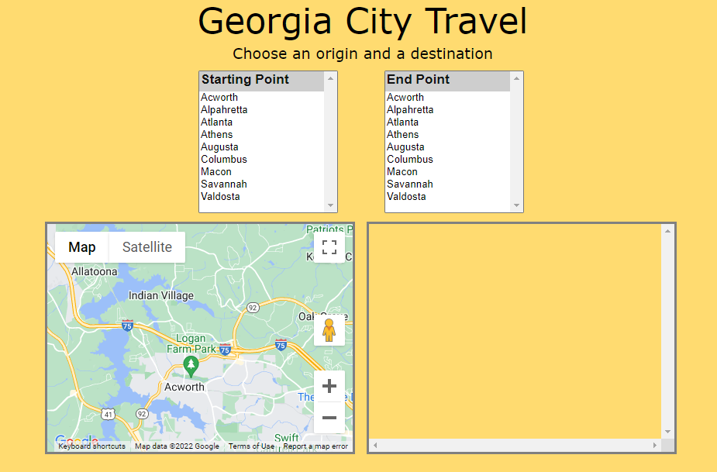

Selecting Cities: